

**UNIVERSITY OF PETROLEUM & ENERGY STUDIES**

**Dehradun**

ACO LAB

**NAME- RADHIKA RAJESH THAKKAR**

**BRANCH- COMPUTER SCIENCE ENGINEERING BATCH- B-4 DEVOPS**

**SAP ID- 500098212 ROLL NO- R2142211496**

**SUBMITTED TO- Dr. Hitesh Kumar Sharma**

**Experiment – 8**

**AIM: Creating Service in Kubernetes**

# Task 1: Start Kubernetes in Docker-Desktop

* Start Kubernetes service in Docker-Desktop

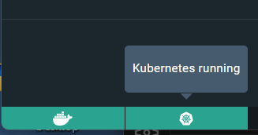

# Task 2: Creating a Service

Create a service to expose the deployed application within the Kubernetes cluster. You can use the following sample YAML manifest as a reference:

apiVersion: V1 kind: Service metadata:

name: my-service spec:

selector:

app: lbnginx ports:

- protocol: TCP port: 80

nodePort: 30001

type: NodePort

* Apply the service using the following command:

# “ kubectl apply -f service.yaml ”

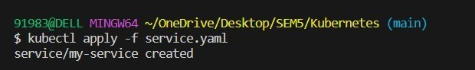

* Verify that the service is created by running the following command:

# “kubectl get services”

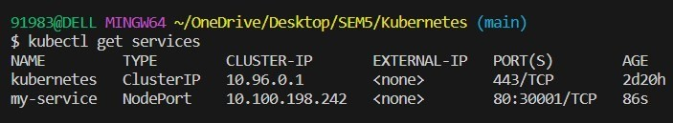

**Task 3: Accessing the Service**

* Access the service using port forwarding. Run the following command:
* Access the Nginx server running in the service by opening a web browser and navigating to

**“ http://localhost:30001 ”**

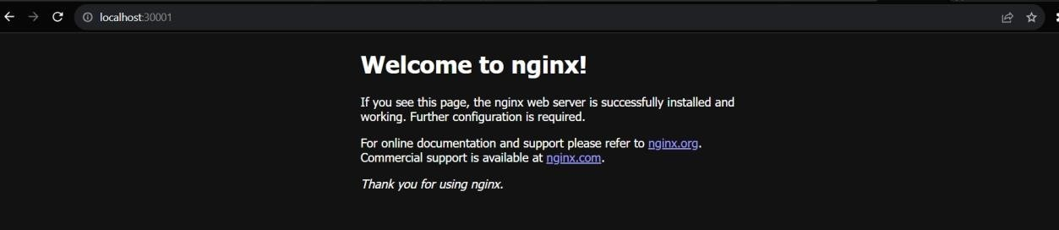

# Task 4: Deleting the Service

* Delete the service using the following command:

# “ kubectl delete service my-service ”

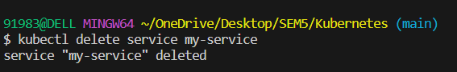

* Verify that the service has been deleted by running the “ kubectl get services”

command.

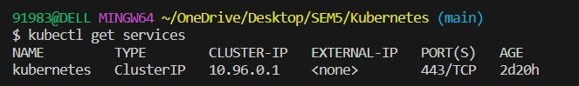

# Task 5: Cleanup

Delete any remaining deployments, services, and resources created during the exercise using the appropriate kubectl delete commands.

# Task 6: Documentation and Best Practices

Document your findings and the best practices for creating and managing services in Kubernetes.

Through this exercise, you'll gain a better understanding of how to create and manage services to expose applications within a Kubernetes cluster. Adjust the exercise based on your specific use case and requirements.